**Experiment 9: Simple application using JSP**

**Aim:** To make a simple application using JSP

**Tags Used:**

<form>

<table>

<tr>

<td>

**Implementation:**

**Output:**

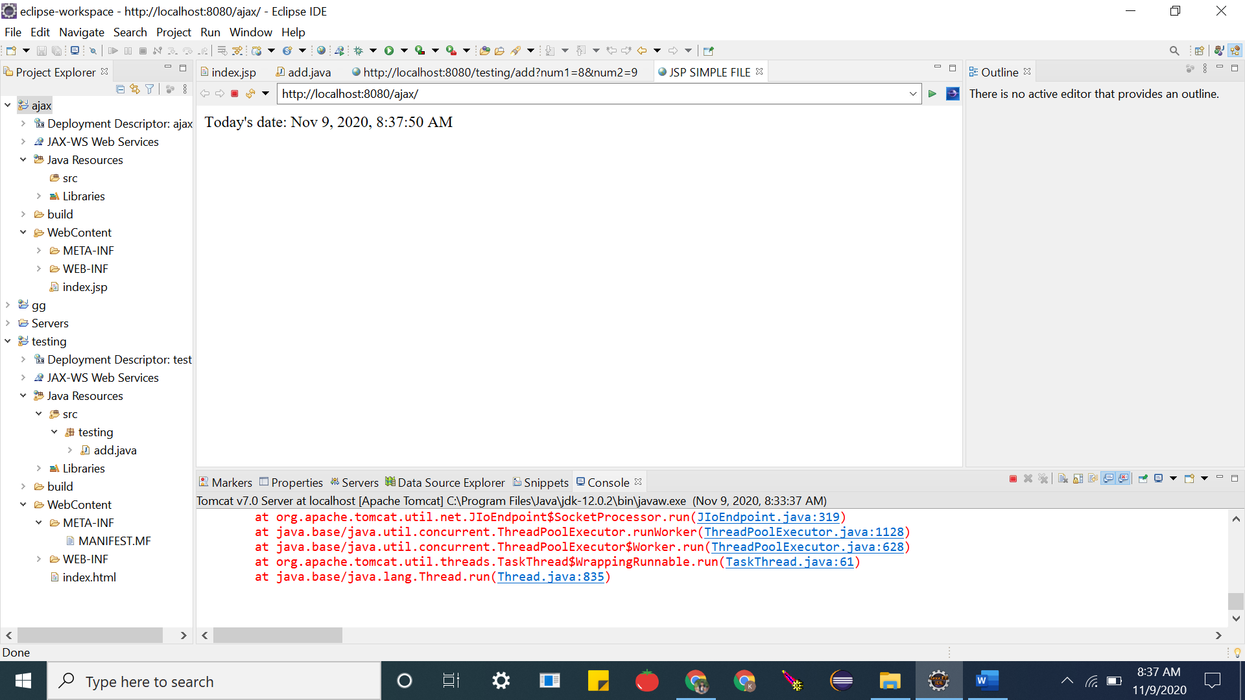

**Code:**

**Index.jsp**

<%@ page language=*"java"* contentType=*"text/html; charset=ISO-8859-1"*

pageEncoding=*"ISO-8859-1"*%>

<!DOCTYPE html>

<html>

<head>

<meta charset=*"ISO-8859-1"*>

<title>JSP SIMPLE FILE</title>

</head>

<body>

Today's date: <%= (**new** java.util.Date()).toLocaleString()%>

</body>

</html>

**Result:**The experiment was successfully completed.